Title of the Article

Author¹*, Author ², and Author ³ (please add this information after acceptance, you only need to input the metadata during submission)

¹ Department, University, Country
² Department, University, Country
³ Department, University, Country
¹email; ²email; ³email
*Corresponding author

Received: 00th May 2024/ Revised: 00th January 2025/ Published: 00th February 2025

Abstract
Abstract is written in English, consisting of 150-250 words, 1 line spacing, and formatted in Times New Roman without bold text. It contains the research objectives, methodology, analysis, and conclusion.
Keywords: it contains 3-5 important words that are taken from the title and the content of the paper

Introduction
It contains the research background, problem formulation, and research objectives, along with a relevant and up-to-date theoretical framework, formatted with 1.5 line spacing.

Literature Review/Theoretical Basis
It contains theories / concepts / approaches / perspectives / paradigms, etc. which will be used to analyse certain cases or selected topics. The naming of the analytical framework may be adjusted or replaced by the names / terms that reflect the conceptual or theoretical framework to be used (e.g. Balance of Power, Soft Power and etc.).

Example of subheading (12 font)
Lorem ipsum dolor sit amet, consectetuer adipiscing elit. Maecenas porttitor congue massa. Fusce posuere, magna sed pulvinar ultricies, purus lectus malesuada libero, sit amet commodo magna eros quis urna. Nunc viverra imperdiet enim. Fusce est. Vivamus a tellus. Pellentesque habitant morbi tristique senectus et netus et malesuada fames ac turpis egestas. Proin pharetra nonummy pede. Mauris et orci. Aenean nec lorem.
In porttitor. Donec laoreet nonummy augue. Suspendisse dui purus, scelerisque at, vulputate vitae, pretium mattis, nunc. Mauris eget neque at sem venenatis eleifend. Ut nonummy. Fusce aliquet pede non pede. Suspendisse dapibus lorem pellentesque magna. Integer nulla. Donec blandit feugiat ligula. Donec hendrerit, felis et imperdiet euismod, purus ipsum pretium metus, in lacinia nulla nisl eget sapien.

Research Methodology
Explain chronological research, including how to prepare materials research, design of the study and research procedures (in the form of an algorithm, pseudocode or other). Minimum research method consists of research type, type and source of data, data collection techniques, and data analysis techniques.

Results and Discussion
It contains the results and analysis done with an emphasis on the answer to the problems. Results can include images, charts, tables, etc. are placed in the middle of the page, and described in the paper.

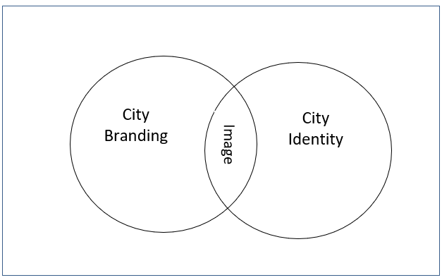
Figure 1. Example of Figure

Table 1. Example of Table
 | Cities | Number of Reviews
1. | Singapore | 1.531.335
2. | Kuala Lumpur | 630.800
3. | Jakarta | 359.581
4. | Ho Chi Minh City | 797.098

Conclusions
It contains an answer or explanation to the problem of research. Moreover, it can also be added to the development prospects of the research and the further application in subsequent studies.

Acknowledgement
Please add information on the funding source (Optional).

Authors’ contributions
Please add a short description about all authors contributions.

Availability of data and material
Please add a short description about availability of data and material.

References
Kuzmina, N., Shirokova, V., Sitnikova, S., & Eltsova, V. (2021). Networking of educational institutions and commercial enterprises. Revista Eduweb, 15(3), 257-270. https://doi.org/10.46502/issn.1856-7576/2021.15.03.22
Brennan, J., King, R., &amp; Lebeau, Y. (2007). Interface : Establishing Knowledge Networks Between Higher Vocational Education and Businesses. Dordrecht: Springer.

